**ANALYSIS REPORT**

**PYTHON PROGRAMMING**

**COMPANY: NETFLIX **

**GROUP MEMBERS;**

**SYED MUHAMMAD MAAZ**

**UZAIR RAEES**

**ZAI UDDIN**

**INTRODUCTION;**

**Netflix, Inc.** is an American [over-the-top content platform](https://en.wikipedia.org/wiki/Over-the-top_media_services) and [production company](https://en.wikipedia.org/wiki/Production_company). Netflix was founded in 1997 by [Reed Hastings](https://en.wikipedia.org/wiki/Reed_Hastings) and [Marc Randolph](https://en.wikipedia.org/wiki/Marc_Randolph) in [Scotts Valley, California](https://en.wikipedia.org/wiki/Scotts_Valley,_California). The company's primary business is a subscription-based [streaming service](https://en.wikipedia.org/wiki/Streaming_service_provider) offering online streaming from a library of films and television series, including those produced in-house. As of October 2020, Netflix had over 195 million paid subscriptions worldwide, including 73 million in the United States.

**RESEARCH OBJECTIVE;**

* To analyze the data of service of company. * What content is most popular on Netflix? * Brand awareness.

**METHODOLOGY;**

It is a Secondary research, we gathered Data from Flixable, which is third-party Netflix search engine.

**DATA;**

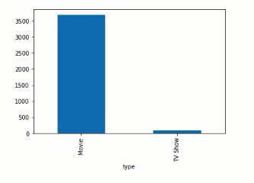

Figure-1 Type of content

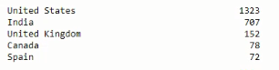

Figure-2 Top 5 countries with the most content

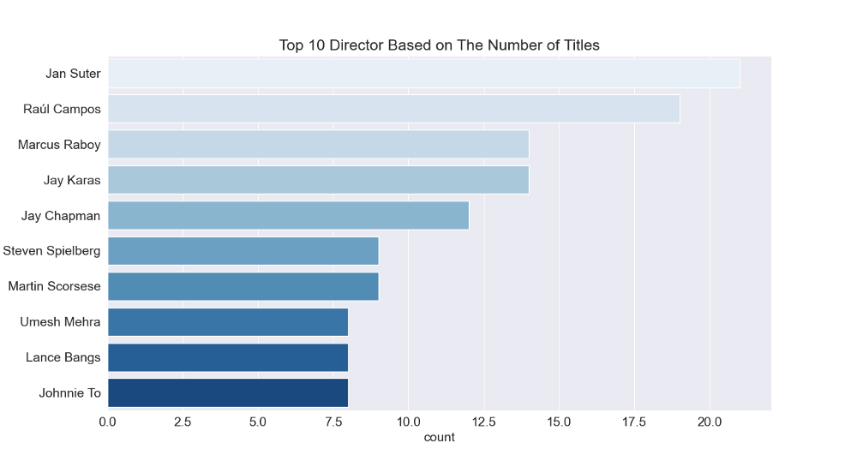

Figure-3 Top 10 popular directors

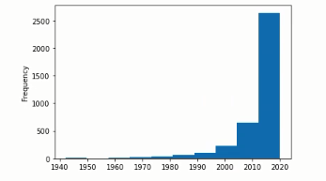

Figure-4 release year

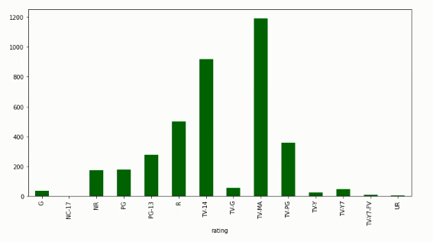

Figure-5 Content ratings

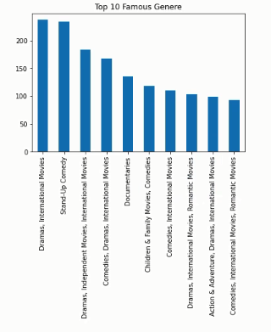 Figure-6 Most famous genres

**ANALYSIS;**

*The most available content type on Netflix is movies.

*According to the statistics the United States accounts for the most of the content created on Netflix with 1323 titles.

* The content present on Netflix was mostly released between the years 2014-2020.

*The most popular director on Netflix, with the most titles, is Jan Suter.

*The largest count of Netflix content is made with a “TV- MA” rating.

*Dramas, comedies and international movies are the genres that are mostly on Netflix

**CONCLUSION;**

The data shows that Netflix has strong content availability with around 6000+ movies and TV shows and the research specify that it offer an excellent range of choices for every age, genre and type that’s why Netflix become most successful media streaming platform with millions of subscribers around the world.